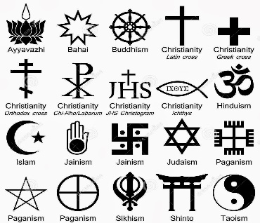  What is a religion? Homework Grid | OPTIONAL!  You can choose to complete enrichment tasks from this homework grid at any point in the year. House points will be awarded for this extra effort. |  | Assessment preparation:  - Do you know at least two definitions of religion?  - Can you name at least 5 features of religion?  - Can you give specific examples of each feature from modern religious practices?  - Can you describe at least 3 things that Pastafarians believe?  - Can you explain how Pastafarians show these beliefs?  - Can you give reasons for your opinion on whether Pastafarianism counts as a religion?
1) Will people in the future think Harry Potter was a religion?  Read this article: https://goo.gl/xt2qgs. You could also do some research of your own into this issue. Then complete a table with two columns – “Reasons to say yes” and “Reasons to say no”. Finish by giving a bullet point explanation of your own opinion. | 2) What are the ‘threads’ of religion?  By our 3rd lesson, you should know about Wittgenstein’s rope analogy. Draw your own ‘rope’ of religion, showing the different features/ characteristics that make up ‘religion’.
3) How do different people define religion?  Do a Google Video search using the term ‘what is religion?’ Select 3 videos to watch and compare. Write 150-200 words about your favourite, explaining the argument/information it gave, why you found it interesting, and why you trust (or don’t!) the source. | 4) What features of religion does Pastafarianism have?  Visit https://en.wikipedia.org/wiki/Flying_Spaghetti_Monster and create a mindmap describing this so-called religion’s history, beliefs and practices. NB Due to the potentially controversial nature of this research topic, parents and carers might wish to supervise students during this research task.
Aiming for EX? Try a Challenge Task!
These give you extra practice in putting together a strong argument. Make sure you consider both sides of the debate (on the other hand), give specific evidence/examples to support your points (for example, take the case of, this means, this shows, this proves), and use counter-arguments to show strengths and weaknesses (but, in spite of, however, despite). You could present this as a written essay, as an illustrated Powerpoint, a speech, even a video.

“Buddhists don’t always believe in God. Therefore Buddhism can’t be called a religion.”  How far do you agree? | “In the modern world, being religious is less about taking part in rituals and more about the way you treat others.”  How far do you agree?

