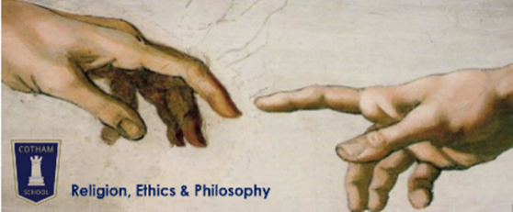
Year 9 Religion, Ethics & Philosophy
Student Guide
Terms 1-2  Do we need religion? | Terms 3-4  What is philosophy for? | Terms 5-6  Why do we suffer?
- Why is neo-paganism becoming popular?  - Is religion just a comfort blanket?  - Has science replaced religion?  - Where can atheists find meaning and purpose? | - Are humans basically good or basically evil?  - What makes me, me?  - How do we decide what’s right and what’s wrong?  - How do we know what’s real? | - Does suffering prove that God doesn’t exist?  - Is suffering worth it?  - Which religious beliefs most help people to cope with suffering?

Home learning | All knowledge organisers and homework grids will also be available on Google Classroom.
Compulsory | You will be given paper copies of a knowledge organiser at the start of every topic. You should complete 30-45 minutes of self-quizzing from this every week. This will be tested with regular knowledge checks in lessons.  As the year goes on, you should continue to include previous topic knowledge organisers in your self-quizzing.
Optional | You can also choose to complete enrichment tasks from each topic’s homework grid. House points will be awarded for this extra effort. If you are aiming to exceed the expected standard then you should complete at least one of these enrichment tasks for every topic.

Assess-  ment | All assessments (including the March exam) will have the same format:  - Closed-book recall of learning from across the year so far  - Open-book extended written response to one of the Big Questions for the current topic
October | - How well can you remember information from our most recent lessons?  - Can you use expert language when making points and do you always support your points with fully explained evidence?  - Can you give at least two different interpretations and make comparisons between them, without needing reminders?
March (exam) | - How well can you remember information over 6 months?  - Can you give a balanced argument using expert language, without needing any prompts?  - When reminded, can you use direct rebuttals to point out flaws in reasoning?  - When reminded, do you ensure that your conclusion flows naturally from the points you have made?
July | - How well can you remember information covered over the whole year?  - Can you give a balanced argument using expert language, without needing any prompts?  - Can you use direct rebuttals to point out flaws in reasoning, without being prompted?  - Does your conclusion entail (flow) naturally from your points?
Exact assessment dates will be shared via Google Classroom at least 2 weeks in advance. Exam dates will be shared via the whole school exam timetable and Google Classroom. NB If you are completing your compulsory self-quizzing homework, you will be prepared well in advance for all assessments!

