What is a religion?  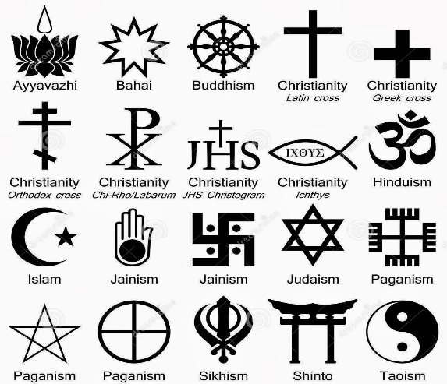  Knowledge Organiser | Characteristics of religions  - Sacred texts/holy books  - Belief in some kind of God and/or an afterlife  - Rules about how to lead your life  - Places to worship  - Prayers and other ways of ‘speaking’ to god  Online Resources  http://www.humanreligions.info/what_is_religion.html  http://www.reonline.org.uk/knowing/what-re/  http://www.bbc.co.uk/religion/religions/atheism/  - Ceremonies around important times in life (rites of passage)  - Relying on faith rather than evidence or proof  - Lots of followers and a long history  - Sincere and genuine belief that influences daily actions.  - Gives a sense of identity, meaning, or purpose.  Aiming for Exceeding? Wittgenstein and the ‘rope’ of religion  - The word religion doesn’t have a single meaning to everyone.  - Like a rope, it is made up of lots of small threads (holy books, prayer, belief etc).  - Removing one ‘thread’ doesn’t mean it is no longer a ‘rope’.  - But perhaps some threads are more important than others…  https://www.youtube.com/watch?v=pQ33gAyhg2c
Key words  - Theist: Someone who does believe in some kind of God or gods.  - Atheist: Someone who does not believe in any kind of God or gods.  - Agnostic: A person who believes that nothing is known or can be known of the existence or nature of God.  - Cult: religion-like organisation not widely respected by society, seen as potentially harmful and possibly involving members being brainwashed.  - Scientology: a belief system often described as a cult, linked to beliefs about aliens and self-improvement  - Pastafarianism: a ‘joke’ religion used by atheists to make a point about the problems of allowing religion to influence political and educational decisions |  | Ninian Smart’s 7 Features of religion:  - Myth: Stories or legends with deeper meanings.  - Ritual: Actions performed as part of a ceremony.  - Organisation: A hierarchy of leadership, where people are given different roles.  - Symbol: Something visible to show beliefs and identiy.  - A Philosophy: An ideal or basic teaching they should follow.  - Ethics: Rules about right and wrong.  - An Experience: An event that leaves an impression on someone.
You should complete 30-45 minutes of self-quizzing from this knowledge organiser every week. This will be tested with regular knowledge checks in lessons. As the year goes on, you should continue to include previous topic knowledge organisers in your self-quizzing.

