Introduction to Humanities  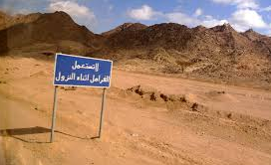  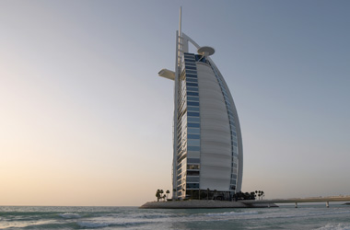  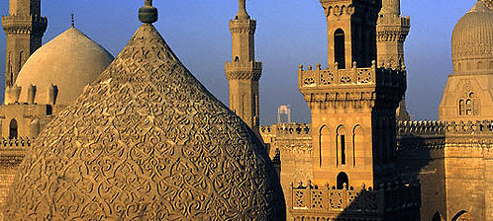  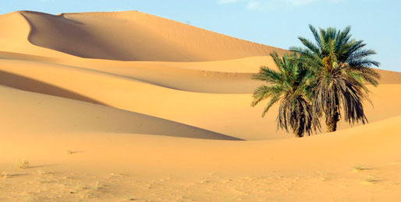  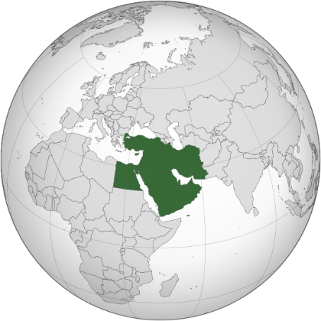  What is life like in the Middle East? | What are the main geographical processes happening in the Middle East  - Climate – the weather in a particular area over a long period of time  - Desert – a region with little or no rainfall (≤250mm per year)  - Evaporation – when water turns into a gas (water vapour) as it heats up  - Lack of insulation – hot in the day, very cold at night  - Desertification – the loss of useful land as it becomes desert  - Migration – people moving to areas within countries and between countries  - Urbanisation – as people move to urban areas they grow to accommodate  - Drought – a lack of water for drinking or farming  - Trade – the Middle East exports a large volume of fuels (mainly oil)
What do we know about the Middle East?  - Made up of 17 countries, some islands, all but one in Asia  - Saudi Arabia is the biggest and Bahrain the smallest  - Along with Bahrain, Cyprus is the other island nation  - Iran is the most populated  - Major rivers in the Middle East include the Nile, Euphrates and the Tigris  - The Middle East isn’t entirely desert, there are mountainous landscapes, semi-arid and Mediterranean climates. | What is the future like for the Middle East?  - What happens when the oil runs out? For the Middle East and the world?  - What has happened to most of Syria’s migrants? Where did they end up and why?  - How are cities like Dubai surviving the desert?  - Can the World Cup in Qatar be sustainable?

Introduction to Humanities  What is life like in the Middle East? | What are the main geographical processes happening in the Middle East  - Climate – the weather in a particular area over a long period of time  - Desert – a region with little or no rainfall (≤250mm per year)  - Evaporation – when water turns into a gas (water vapour) as it heats up  - Lack of insulation – hot in the day, very cold at night  - Desertification – the loss of useful land as it becomes desert  - Migration – people moving to areas within countries and between countries  - Urbanisation – as people move to urban areas they grow to accommodate  - Drought – a lack of water for drinking or farming  - Trade – the Middle East exports a large volume of fuels (mainly oil)
What do we know about the Middle East?  - Made up of 17 countries, some islands, all but one in Asia  - Saudi Arabia is the biggest and Bahrain the smallest  - Along with Bahrain, Cyprus is the other island nation  - Iran is the most populated  - Major rivers in the Middle East include the Nile, Euphrates and the Tigris  - The Middle East isn’t entirely desert, there are mountainous landscapes, semi-arid and Mediterranean climates. | What is the future like for the Middle East?  - What happens when the oil runs out? For the Middle East and the world?  - What has happened to most of Syria’s migrants? Where did they end up and why?  - How are cities like Dubai surviving the desert?  - Can the World Cup in Qatar be sustainable?

