Introduction to Humanities  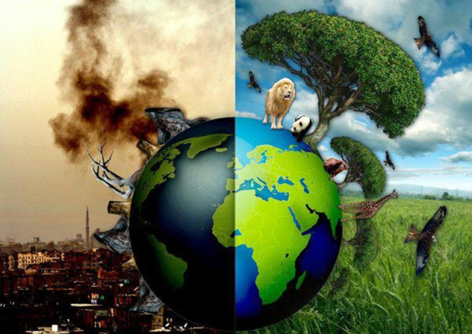  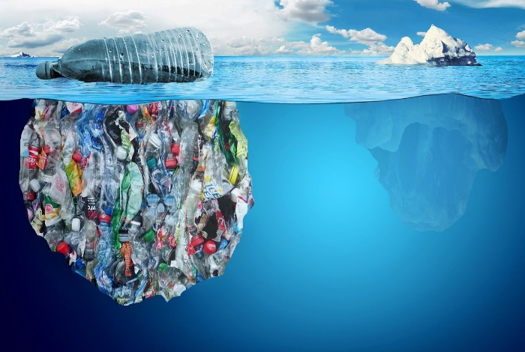  Can we save the world? | The treatment of people due to Globalisation  - Sadly people can lose out when big companies globalise. They are used to make more profits and sometimes not respected  - In many examples workers are treated poorly, work in harsh conditions, have very little say and don’t get the protection they deserve in the workplace  - This led to a growth of the sweatshop issue (workplaces/factories). These are the manufacturing locations run by big Multinationals who make as much profit but treat their workers poorly.  - In certain parts of the world (Qatar, Brazil) people have been treated badly by having their homes removed, or their human rights in order to construct facilities and stadia for large sporting events.  - Many global companies want to have an ethical face and have tried to close and avoid the use of sweatshops e.g. Nike, Adidas, Reebok.
Globalisation  - Globalisation is the process of the way the world is more linked together. People around the world are more connected by trade, culture and media.  - The world isn’t physically smaller but we can get information around much faster. As a result the world is classed as shrinking (transport is quicker, electronic information moves instantly)  - Many global companies (Multi nationals) have taken advantage of the globalisation of the world. As a result big brands can be found in most countries  - Multi-national companies have expanded to make bigger profits. Sometimes at the expense of people and/or the environment  - Some of the biggest brands worldwide are fast food and sporting companies. | The Plastic problem and food miles  - Plastics are a big environmental issue and this is linked to the pollution effects we are having on the oceans  - 10 major world river (8 from Asia) are responsible for 90% of all plastic pollution in the oceans  - Plastic takes around 450 years for a single bottle to degrade. All plastic in the sea therefore has yet to degrade.  - Plastic in the food chain is a big issue. Some governments recently banned microbeads (the little plastic beads found in shower gels and bath products)  - Plastic can be toxic to or choke animals that eat it. Eventually it can get into our food chain.  - The more food we transport around the world and food in too much plastic further adds to the problem. We have to be conscious about shopping local

Introduction to Humanities  Can we save the world? | The treatment of people due to Globalisation  - Sadly people can lose out when big companies globalise. They are used to make more profits and sometimes not respected  - In many examples workers are treated poorly, work in harsh conditions, have very little say and don’t get the protection they deserve in the workplace  - This led to a growth of the sweatshop issue (workplaces/factories). These are the manufacturing locations run by big Multinationals who make as much profit but treat their workers poorly.  - In certain parts of the world (Qatar, Brazil) people have been treated badly by having their homes removed, or their human rights in order to construct facilities and stadia for large sporting events.  - Many global companies want to have an ethical face and have tried to close and avoid the use of sweatshops e.g. Nike, Adidas, Reebok.
Globalisation  - Globalisation is the process of the way the world is more linked together. People around the world are more connected by trade, culture and media.  - The world isn’t physically smaller but we can get information around much faster. As a result the world is classed as shrinking (transport is quicker, electronic information moves instantly)  - Many global companies (Multi nationals) have taken advantage of the globalisation of the world. As a result big brands can be found in most countries  - Multi-national companies have expanded to make bigger profits. Sometimes at the expense of people and/or the environment  - Some of the biggest brands worldwide are fast food and sporting companies. | The Plastic problem and food miles  - Plastics are a big environmental issue and this is linked to the pollution effects we are having on the oceans  - 10 major world river (8 from Asia) are responsible for 90% of all plastic pollution in the oceans  - Plastic takes around 450 years for a single bottle to degrade. All plastic in the sea therefore has yet to degrade.  - Plastic in the food chain is a big issue. Some governments recently banned microbeads (the little plastic beads found in shower gels and bath products)  - Plastic can be toxic to or choke animals that eat it. Eventually it can get into our food chain.  - The more food we transport around the world and food in too much plastic further adds to the problem. We have to be conscious about shopping local

