Religion, Ethics & Philosophy  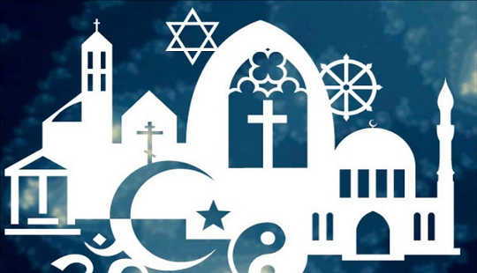  What Do People Believe About God? | 1) Does God even exist?  - theist – someone who believes in some kind of God or gods  - atheist – someone who does not believe in any kind of God or gods  - agnostic – someone who thinks we cannot know whether there is a God or not | 2) Why don’t Jews have a name for G-d?  - Judaism – a monotheistic religion with Moses as an important leader  - Jew – follower of Judaism  - Blasphemy – showing disrespect to God  - Jehovah – ‘I Am Who I Am’ – Hebrew word for God
3) Why do Muslims have so many names for Allah?  - Islam – a monotheistic religion with Muhammad (pbuh) as its most important leader  - Muslim – follower of Islam  - Allah – Arabic word meaning God  - Tawhid – Arabic word meaning the Oneness of God  - Monotheism – believing in only one God | 4) Do Hindus worship one God or many gods?  - Polytheism – believing in many different gods  - Trimurti – three gods representing the cycle of life: Create, Maintain, Destroy  - Brahman  - avatar – a god that has taken the form of a human  - atman – the part of all living creatures that is God, our soul | 5) What do Christians mean when they say that Jesus was God?  - The Incarnation - God becoming fully human in the form of Jesus  - miracle – an event that cannot be explained by science  - crucifixion – a painful method of execution used on Jesus  - resurrection – coming back to life
6) Why do Sikhs see truth in all beliefs about God?  - Guru – Punjabi word meaning ‘teacher’  - Mool Mantar - Punjabi phrase meaning ‘basic teaching’ – the most important prayer of Sikhism | 7) Why don’t Buddhists talk about God?  - Buddha – a person who has achieved Enlightenment and returned to help others  - non-theist – someone who is not interested in questions of God  - deva – a superhuman being | 9) What makes God worth worshipping?  - Omnipotent – all-powerful, able to do anything  - Omnibenevolent – all-loving, always acts for god and out of love
8) What do I believe about God? Use this space to list the important words and ideas you would use to explain YOUR beliefs about God

