**Jesus and redemption/salvation**

**Christian names for Jesus**

**The Messiah**: Hebrew for the Chosen One, promised by Old Testament prophecies (see also **Christ**, Greek word for the same).

**God Incarnate:** God in human form

**Lamb of God:**  lambs were a common sacrifice in Judaism – a reminder of Jesus’ death on the cross

**Saviour or Redeemer**: A reminder that Jesus’ sacrifice saved humans from sin.

**God:** A/The supreme being

**Omnipotent**: All powerful

**Omniscient:** All knowing

**Omnibenevolent:** All loving

**Justice:** Fairness, equality, punishing bad and rewarding good

**Grace**: The unconditional and generous love that God shows to people who do not deserve it.

**Monotheistic:** A religion that believes there is only one God.

**Trinity:** The belief that there are three Persons in the One God. The Father, Son and Holy Spirit are separate, but are also one being.

**Father:** The first person in the Trinity; the creator and sustainer

**Son of God**: Jesus as the third person of the Trinity – both God and God’s son – the Messiah and humanity’s Redeemer.

**Holy Spirit**: The third person of the Trinity; God as spiritually active in the world.

**Creation:** Christians believe that the world is God’s loving creation.

**The Word:** John’s Gospel describing God creating the world through his Word, including Jesus and the holy Spirit.

**Genesis**: The first book in the Bible, which explains the creation story.

**Sin:** any action (or thought) that separates humans from God; going against God’s will.

**Redemption**: To ‘buy out’ – a reference to Jesus taking on humanity’s punishment and ‘earning’ us a new relationship with God.

**Salvation:** Being saved, in this case, from sin and eternal separation from God (hell).

**SOURCE TO REMEMBER**

**Apostles’ Creed:** prayer that declares faith in the core Christian beliefs.



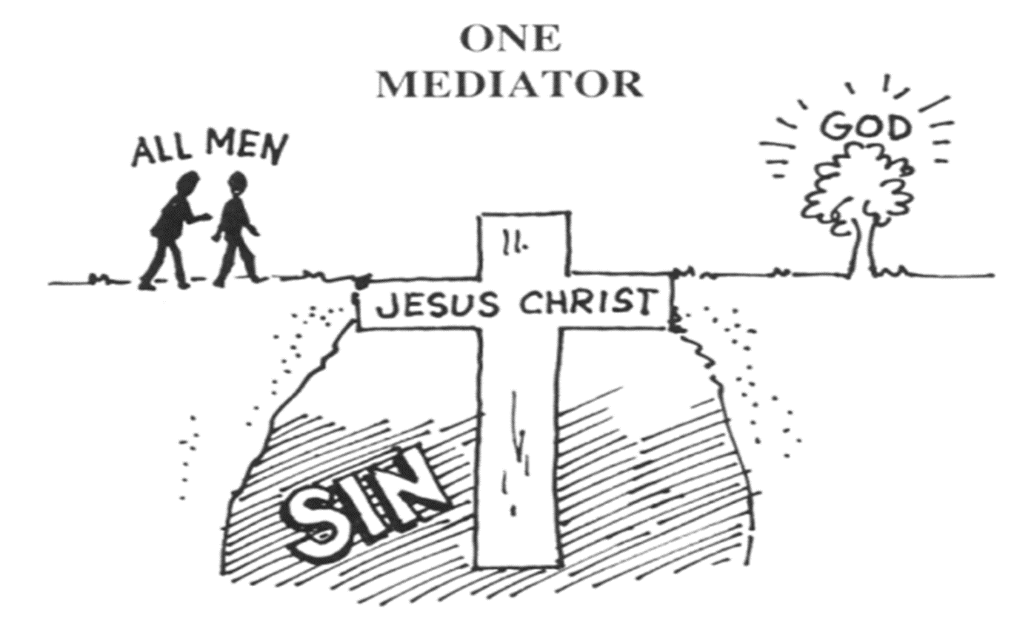

**The Problem of Evil**

If God is omnipotent, omniscient and omnibenevolent then why is there so much suffering in the world?

**Christian responses to the problem**

* Augustine believed there is suffering due to the actions of Adam and Eve (eating the forbidden fruit).
* Irenaeus believed that we need suffering in order to grow as people.
* Dualism is the belief that we need bad in order to have good.
* Some Christians believe suffering is a test, as explained in the Story of Job
* Some people argue that suffering is the price we pay for having free will; suffering would only end if God controlled our actions.

**God’s Characteristics**



**How does salvation work? i.e. how do humans get into heaven?**

**Salvation through Spirit**

* The Holy Spirit gives humans the strength to stick to God’s rules.

**Paper 1: Christian Beliefs**

**Knowledge Organiser**

omniscient omnibenevolent omnipotent just

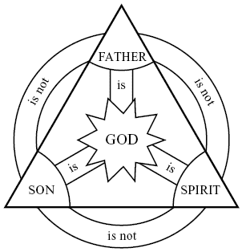

**Salvation through God’s grace (PROTESTANT)**

* No human can live a perfect life. Technically none of us deserve to go to Heaven.
* We can only get to Heaven because of God: Jesus sacrifice, and God’s forgiveness.

**Salvation through law/works (CATHOLIC)**

* 10 Commandments & Jesus’ teachings (esp. Parable of the Sheep & Goats) tell us how to live our life.
* If we stick to these rules we can get to Heaven. When we make mistakes, we can ask forgiveness through the sacrament of Reconciliation.

**Logos**: Ancient Greek for ‘The Word’ – used by John to refer to both God and Jesus

**SOURCES TO REMEMBER**

**Genesis:** The seven-day creation story where the Father is seen as the creator – also contains the story of The Fall (The Garden of Eden, Adam & Eve).

**Gospel of John:** This account also includes Jesus’ role in creation.

**The Holy Trinity**