History Unit 2  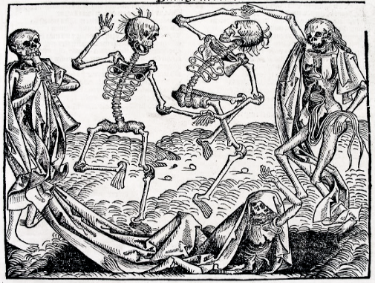  What was Medieval life, beliefs and ideas like? | - How did ordinary people live in medieval times?  Life was very different in medieval times and was often organised around the layout of a village.  The Lord of the manor owned the land with the people living on it, working for them.  Village life was not all misery. Holy days meant a day off work. Peasant fun was rough – wrestling, shin-kicking and cock-fighting. | 2. What was life like for a villein?  A Villein is someone who is owned by a feudal lord and has to work for his or her lord.  The medieval peasant's life was hard and the work back-breaking. It followed the seasons – ploughing in autumn, sowing in spring, harvesting in August. Work began at dawn, preparing the animals, and it finished at dusk
3. What did Medieval people believe in?  Many Christians in medieval England went to Church and religion was an important part of their life  The Church taught that-  -Most people did not go straight to Heaven or Hell but to purgatory instead.  -souls would remain in purgatory until their sins were gone, some would end up going to Hell | 4. What did medieval people know about health and medicine?  For many peasants in Medieval England, disease and poor health were part of their daily life.  Medicines were both basic and often useless.  Towns and cities were filthy and knowledge of hygiene was non-existent. | 5. What were the different crimes and punishments in medieval times?  There were no policeman in the middle ages, law and order was down to the villagers  The Hue and Cry was when you shouted loudly to try and track down the criminal  Punishments could include- hanging, drawing, being burned alive, fines, whipping or the stocks.
6. Should we look back at the past and make moral judgement on people’s actions?  We should learn not to make too harsh moral judgements about people of the past and their decisions.  People throughout history have been put under much different and difficult circumstances and it is important to study their environment. | 7. What was the Black Death?  The plague arrived in Dorset in June 1348 and it spread throughout the south of England.  One in three people in England died of it and crops rotted in fields because no one was alive to harvest them  Historians suggest that the Black Death helped to cause the Peasants' Revolt. | 8. Why did the Peasants Revolt in 1381?  The three reasons why peasants revolted were-  1. Taxes  2. Wanting to be Free and Equal  3. They were unhappy with King’s Advisers  Poll tax – a tax where everyone has to pay the same amount of money

