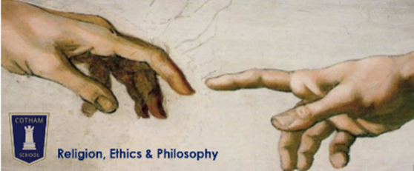
AQA GCSE in Religious Studies A (excluding textual studies option): 8062A – full course
Year 10 Religion, Ethics & Philosophy
Student Guide
 | Paper 1: The Study of Religions | Paper 2: Thematic Studies
Content | - Christian Beliefs  - Christian Practices  - Muslim Beliefs  - Muslim Practice | - Religion & Life  - Peace & Conflict  - Crime & Punishment  - Human Rights & Social Justice
Format | 4x 5-part questions worth 1, 2, 4, 5 and 12 marks | 4x 5-part questions worth 1, 2, 4, 5 and 12 marks
Time | 1 hour 45 minutes | 1 hour 45 minutes
Marks | 96 + 5 SPaG | 96 + 5 SPaG
Worth | 50% | 50%

Year 10 Schedule
Term | 1 | 2 | 3 | 4 | 5 |  | 6
Ms Almey | Christian Beliefs |  | Human Rights & Social Justice |  |  | Christian Practices
Miss Moore | Religion & Life |  | Muslim Beliefs
Formal assessment | In-class exam – 1 hour: w/c 10 Dec |  | Multiple choice knowledge check on all content – 45 minutes: late May |  |  |  | Full mock exam – 1 hour 45 mins: 17-26 June

Home Learning
All knowledge organisers and exam practice grids will be available on Google Classroom and the VLE. Specific assignments will be set via Google Classroom. The resources provided ensure that you ALWAYS have work you can be doing independently.
Revision | You will be given paper copies of a knowledge organiser at the start of every topic. You should complete 30 minutes of self-quizzing from this every week. This will be tested with regular knowledge checks in lessons. As the year goes on, you should continue to include previous topic knowledge organisers in your self-quizzing. You also have your own copy of the course textbooks, which contain lots of tasks to review and consolidate your learning. Sometimes you will be directed to complete specific tasks
Exam practice | You will also be given a grid of practice exam questions for each topic. Your teacher will direct you to complete specific examples at specific times – sometimes as you are being taught the content, sometimes as revision later in the course. But you should also use these grids to support your own independent exam practice.
Challenge | Websites  https://www.youtube.com/user/crashcourse/videos  http://plato.stanford.edu  http://rsrevision.com  https://www.youtube.com/user/jointhebibleproject/videos | Books  The Pig Who Wants To be Eaten – Julian Baggini  The Philosophy Files – Stephen Law  The God Delusion – Richard Dawkins  Philosophy: A Graphic Guide – Dave Johnson & Judy Groves  The Puzzle of God, The Puzzle of Evil, The Puzzle of Ethics – Peter Vardy  A History of God – Karen Armstrong

Textbooks
Copies provided | Recommended for purchase
- OUP Religious Studies A Islam – personal copy  - OUP religious Studies A Christianity – personal copy  - Hodder AQA GCSE Religious Studies Specification A – in lessons only | - Hodder AQA GCSE Religious Studies Specification A

