Religion, Ethics & Philosophy
A-Level Year 1
Student Guide & Reading Lists
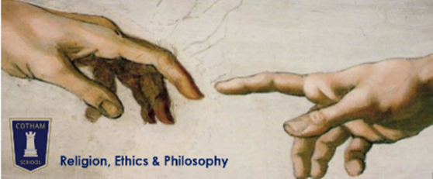
Ms Almey  almeyl@cotham.bristol.sch.uk  Teaching room: A104 | Miss Moore  moorer@cotham.bristol.sch.uk  Teaching room: A105

All lesson resources and home learning assignments available on

Course details
Official title: OCR Level 3 Advanced GCE in Religious Studies (H573). Full specification available at: ocr.org.uk/alevelreligiousstudies

Exam format and assessment objectives
Exam paper | Philosophy of Religion (H573/01) | Religion & Ethics (H573/02) | Developments in Christian Thought (H573/03)
Worth | 33.3%
Maximum marks | 120
Time | 2 hours
Essays to write | 3
Choice from | 4
Basic timing | 40 mins per essay
Maximum marks per essay | 40 marks per essay

Assessment Objective: |  | % of marks
AO1 | Demonstrate knowledge and understanding of religion and belief, including:  - Religious, philosophical and/or ethical thought and teaching  - Influence of beliefs, teachings and practice on individuals, communities and societies  - Cause and significance of similarities and differences in belief, teaching and practice  - Approaches to the study of religion and belief | 40%
AO2 | Analyse and evaluate aspects of, and approaches to, religion and belief, including their significance, influence and study | 60%

Content
 | Terms | Philosophy of Religion | Religion & Ethics | Developments in Christian Thought
Year 12 | 1-2 | - Ancient Philosophical Influences  - Soul, Mind & Body  - The Problem of Evil | - Natural Moral Law  - Situation Ethics  - Kantian Ethics  - Utilitarianism
 | 3-4 | - Proofs of God  - Religious Experience | - Euthanasia  - Business Ethics | - Augustine & Human Nature
 | 5-6 |  |  | - Knowledge of God  - Christian Moral Principles & Actions  - Death & The Afterlife  - The Person of Jesus Christ
Year 13 | 1-2 | - The Nature of God  - Religious Language | - Meta-Ethics  - Conscience
 | 3-4 | - Religious Language | - Sexual Ethics | - Religious Pluralism  - Gender
 | 5 |  |  | - Secularism  - Liberation Theology & Marx

What to expect
You will be spending the majority of your time taking part in three basic types of activity:
- Reading and analysis of texts
- Debating, discussing and reflecting
- Planning and writing entire essays, or sections of essays
This doesn’t mean you have to start the course as a champion speed reader, expert debater, or budding author. But you do need to be willing to develop your skills in these areas, and to participate fully in every aspect of lessons and home learning.

Assessment and feedback
You will be formally assessed at three points in Year 12:
- Early November – 90 minutes, 2 essays from a choice of 4
- Late February – 90 minutes, 2 essays from a choice of 4
- Late May/early June – 2 hours, 3 essays from a choice of 6
These assessments will cover ALL content covered so far in the course and require you to continuously revise throughout the year. You will only receive grades on these 3 formal assessments.
In between these assessments you will complete a range of tasks (written and verbal) designed to develop and test your knowledge, comprehension and essay skills. We will use these tasks to give you feedback and help you to improve. You will receive some limited written feedback, but much of the guidance you receive will be verbal e.g. one-to-one interviews, small group interviews, whole class feedback. Self and peer assessment will also be a regular feature of lessons and home learning.

Attendance and punctuality
You are expected to complete home learning tasks set during your absence, and to independently use the lesson resources on Google Classroom to catch up on work missed. Please do not email your teacher asking what you missed. Students who routinely arrive late will be put on a stage 1 contract, and may be turned away to avoid interrupting the lesson.

Making notes
Your notes should be made on A4 paper. For at least the first 6 months of Year 12, all students are required to use the Cornell note taking system. Once you can show that you’ve embedded the principles behind Cornell, you can adapt the system to suit your needs.
We also expect to see annotations on all hand-outs, worksheets etc.

Home learning
You should complete 9 hours of home learning for this subject every week (‘an hour for an hour’) – this will include:
- Reviewing notes after every lesson, and again before the next lesson (Cornell-style)
- Wider reading and note taking from the set reading lists
- Acting on feedback e.g. re-drafting and corrections
- Self-quizzing from notes and knowledge organisers
- Specific home learning assignments set on Google Classroom
You are expected to check Google Classroom at least once each day for announcements and updates.
Failing to complete home learning could result in a your being unable to participate in the next lesson’s activities and learning.
NB For essay-based tasks we will give you a cover sheet that needs to be completed and secured to the front of your essay on submission. Essays submitted without a completed coversheet will not receive written feedback.

Improvement work
We will regularly provide you with feedback on your work – in writing, verbally, in one-to-ones, small groups and to the whole class. You are expected to act upon this feedback by annotating, amending or re-drafting selected parts of your work. Please complete this as per your teacher’s instructions and be prepared to show evidence of it during folder checks.

Folder & equipment
You need a large lever arch folder to organise all notes and handouts in. You will need to buy some tabbed dividers to organise these notes.
Your folder must be kept up-to-date and organised. Please do not store your notes in plastic wallets, or in notebooks that are not hole-punched or don’t allow for easy removal of pages.
We will conduct regular folder checks to help you keep your folder organised and check for completion of Cornell reviews, catching up on missed work, improvements to essays etc.
You must have your folder with you in every lesson, along with your course textbook, A4 lined paper, a pen (and spare), pencil and ruler.

Religion, Ethics & Philosophy Reading List – Year 1
Essential reading – available from library | Strongly recommended – not available in the library
- Hodder Education (2016) – Wilkinson, Wilcockson, Campbell – OCR Religious Studies for A Level Year 1  - Vardy & Grosch (1999) The Puzzle of Ethics  - Vardy (2016) The Puzzle of Christianity  - Vardy (1999) The Puzzle of God  - Vardy (1992) The Puzzle of Evil | - Oxford University Press (2016) – Ahluwalia, Bowie – Religious Studies for OCR Year 1  - Peped (2017) – Capone, Dunsmore, Baron – OCR Revision Guide New Spec Year 1 – Religious Studies Bundle  - Peped (2016 2nd edition) – Baron – How to Write Philosophical Essays for Religious Studies A Level

Philosophy of Religion | Author | Cost
1. The Philosophy Files | Stephen Law | £1.88
2. The God Delusion | Richard Dawkins | £2.14
3. Teach Yourself Philosophy of Religion | Mel Thompson | £2.69
4. Philosophy A Graphic Guide | Dave Johnson & Judy Groves | £2.54
5. 50 Philosophy Ideas | Ben Dupre | £5.14
6. The autobiography of Saint Teresa | Saint Teresa | £2.81
7. Consciousness; an introduction | Susan Blackmore | £2.88
8. The Blind Watchmaker | Richard Dawkins | £2.95
9. Principles of Philosophy | Rene Descartes | £4.00
10. Idea of the Holy | Rudolf Otto | £5.81
11. An Introduction to Plato’s Republic | Julia Annas | £7.67
12. The Concept of the Mind (Penguin) | Ryle Gilbert | £8.23
13. God, Freedom and Evil | Alvin Plantinga | £9.81
14. Intro. to the Philosophy of Religion | Brian Davies | £12.21
15. The Question of God | Michael Palmer | £16.45
http://plato.stanford.edu/entries/plato/ http://plato.stanford.edu/entries/ancient-soul/
www.teachphilosophy101.org www.reddit.com/r/philosophy
www.philosophybites.com https://www.youtube.com/user/crashcourse/videos
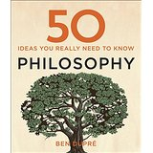
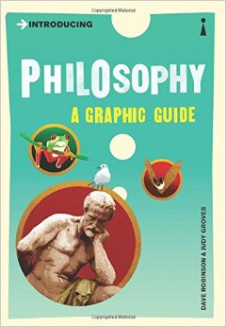
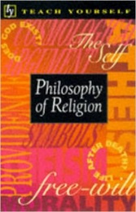
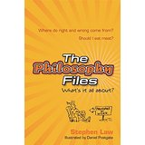
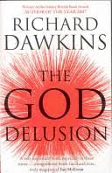
1 | 2 | 3 | 4 | 5

6 | 7 | 8 | 9 | 10
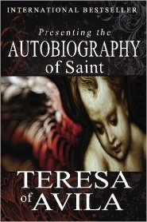
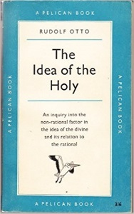
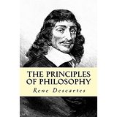
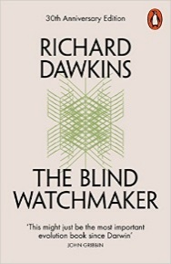
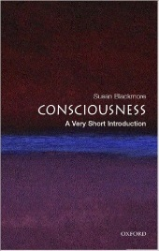

11 | 12 | 13 | 14 | 15

Religion & Ethics | Author | Cost
1. Puzzle of Ethics | Peter Vardy | £2.28
2. Ethical Studies | Robert Bowie | £2.81
3. A very short introduction to Ethics | Simon Blackburn | £2.81
4. The Moral Philosophers: An Introduction to Ethics | Richard Norman | £4.08
5. Understand Ethics | Mel Thompson | £6.82
6. Catechism of the Catholic Church | Geoffrey Chapman | £2.81
7. Situation Ethics – The New Morality | Joseph Fletcher | £2.81
8. Causing Death and Saving Lives (Penguin) | John Glover | £2.81
9. Practical Ethics | Peter Singer | £2.92
10. Business Ethics | Andrew Crane | £3.06
11. Utilitarianism | John Stuart Mill | £3.50
12. Christian Ethics: A Very Short Introduction | D. Stephen Long | £3.92
13. Ethics: Discovering Right and Wrong | Louis Pojman | £4.45
14. The Four Loves | C.S Lewis | £5.21
15. Physics (Oxford World's Classics) | Aristotle | £5.51
16. An introduction to the morals and principles of legislation | Jeremy Bentham | £7.89
17. Rethinking Life and Death: | Peter Singer | £8.03
18. Ethical Theory | Russ Shafer-Endau | £9.03
http://plato.stanford.edu https://www.youtube.com/user/crashcourse/videos www.peped.org
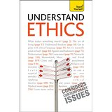
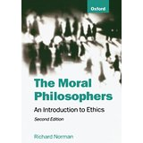
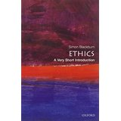
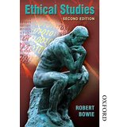
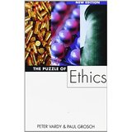
1 | 2 | 3 | 4 | 5

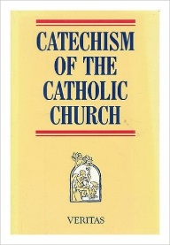  6 | 7 | 8 | 9 | 10

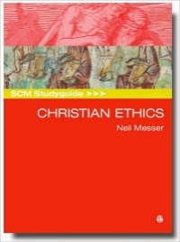
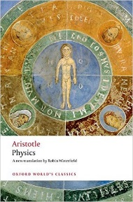
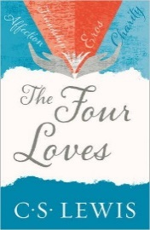
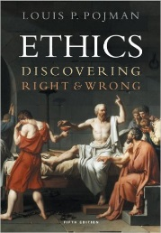
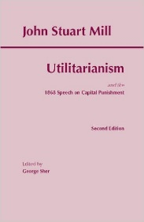
11 | 12 | 13 | 14 | 15

16 | 17 | 18

Developments in Christian Thought | Author | Cost
1. The Shack | William Young | £1.87
2. The Story of the Book | Terence Copley | £2.79
3. Christianity – A Very Short Introduction | Linda Woodhead | £2.81
4. Teach Yourself Christianity | John Young | £2.81
5. History of Christianity | Nick Page | £7.51
6. Confessions | Saint Augustine | £2.81
7. Catechism of the Catholic Church | Catholic Church | £2.81
8. Christian Theology | Alistair McGrath | £2.82
9. Institutes of the Christian Religion | John Calvin | £7.99
10. Shadow of the Galilean | Gerd Theissen | £8.73
11. City of God | St. Augustine | £10.95
12. A Theology, The Basics | Alistair McGrath | £12.74
13. SCM Study Guide to Ethics | Neil Messer | £14.10
14. Death and Eternal Life | John Hick | £28.27
http://plato.stanford.edu www.peped.org https://www.youtube.com/user/jointhebibleproject/videos
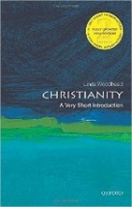
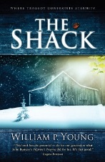
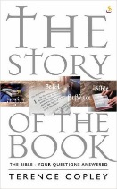
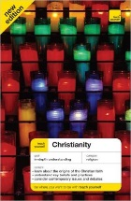
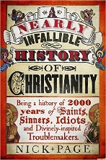
1 | 2 | 3 | 4 | 5

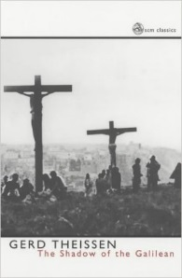
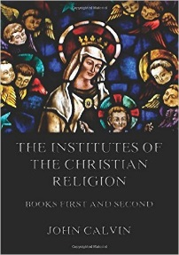
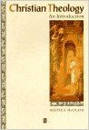
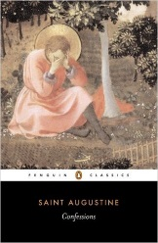

6 | 7 | 8 | 9 | 10

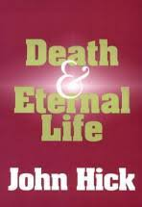
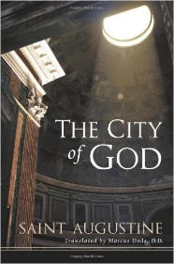
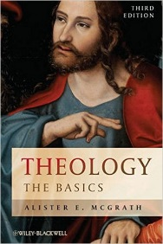
11 | 12 | 13 | 14

Aiming for A/A*?
Podcasts | 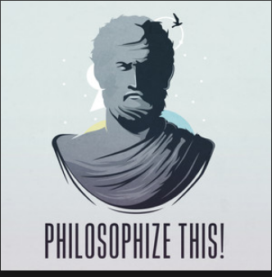 | 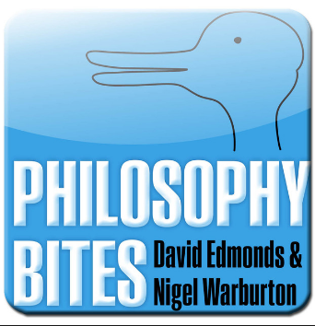 | 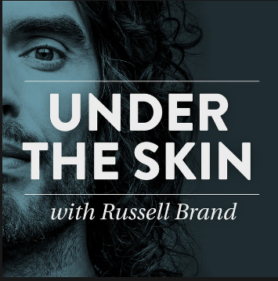 | Available on Spotify, iTunes and any good podcast app
Radio shows | 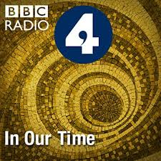 | 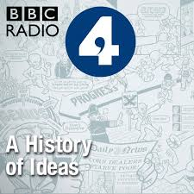 | 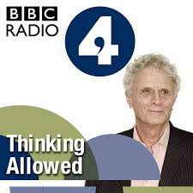 | Available on BBC iPlayer Radio
Adam Curtis documentaries |  | 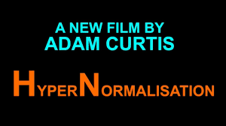 |  | Available on BBC iPlayer
 |  | 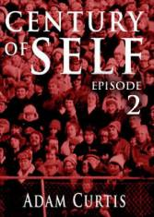 | 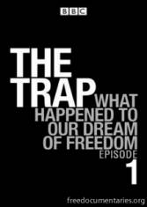 | Available on freedocumentaries.com

