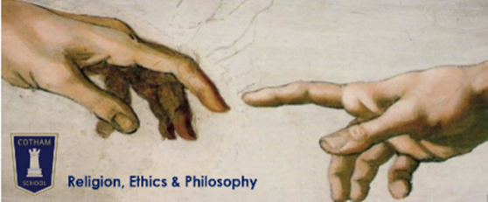
Year 8 Religion, Ethics & Philosophy
Student Guide
Term 1-2  What is religion? | Term 3-4  What does it mean to be Muslim? | Term 5-6  Why does Jesus matter today?
- Is religion defined by beliefs, or by behaviours?  - What has Jediism got in common with religion?  - Does atheism count as a religion?  - Is Scientology a religion or a cult?  - Do Pastafarians deserve religious freedoms? | - Which matters more to Muslim identity - beliefs or behaviour?  - What might be most challenging about leading a halal lifestyle?  - Should Muslim women all wear the hijab?  - Can Sunni and Shi’a Muslims worship in the same mosques? | - Do you have to be Christian to have respect for Jesus?  - Which of Jesus’ teachings has the most importance today?  - Did Jesus’ death matter more than his life?  - How can we imagine Jesus?

Home learning | All knowledge organisers and homework grids will also be available on Google Classroom.
Compuls-ory | You will be given paper copies of a knowledge organiser at the start of every topic. You should complete 30-45 minutes of self-quizzing from this every week. This will be tested with regular knowledge checks in lessons. As the year goes on, you should continue to include previous topic knowledge organisers in your self-quizzing.
Optio-nal | You can also choose to complete enrichment tasks from each topic’s homework grid. House points will be awarded for this extra effort. If you are aiming to exceed the expected standard then you should complete at least one of these enrichment tasks for every topic.

Assess-  ment | All assessments (including the March exam) will have the same format:  - Closed-book recall of learning from across the year so far  - Open-book extended written response to one of the Big Questions for the current topic
October | - How well can you remember information covered over 2 months?  - Can you use expert language when making points?  - Do you routinely use evidence or examples to support your points?  - Do you, when prompted, explain how your evidence supports your point and link back to the question?  - Do you, when prompted, make sure you have included points from both sides of the argument?
February (exam) | - How well can you remember information covered in 6 months?  - Can you use expert language when making points and support your points with evidence and examples?  - Do you routinely explain your evidence, linking back to the question?  - Do you include points from different sides of the argument?  - When prompted, can you make comparisons between different ideas?
July | - How well can you remember information covered over the whole year?  - Can you use expert language when making points and do you always support your points with fully explained evidence?  - Can you give at least two different interpretations and make comparisons between them, without needing reminders?
Exact assessment dates will be shared via Google Classroom at least 2 weeks in advance. Exam dates will be shared via the whole school exam timetable and Google Classroom. NB If you are completing your compulsory self-quizzing homework, you will be prepared well in advance for all assessments!

